Memorandum

To: Professor Deborah Sills and Professor Matthew Higgins

From: Tyler Bell

Lab Partner: Taylor Sisti

Date: 9/24/2013

Subject: Chlordane Sorption

Dear Professor Sill and Professor Higgins,

**Objective**

The objective of the experiment was to plot the data found in the field with respect to two sorption isotherms, Linear and Freundlich.

**Methods**

KaleidaGraph was the program that was used to plot the data collected in the field. The graphs of the isotherm models were plotted with the Caq vs. Cadsorbed data points that were determined by using equations 1 and 2 found below. Equation 1 describes the linear sorption isotherm model and equation 2 describes the Freundlich sorption isotherm model.

$q=KC$ (1)

$q=KC^{\frac{1}{n}}$ (2)

Where:

q = mass of adsorbate adsorbed per mass of adsorbent at equilibrium (mg / g),

C = concentration of adsorbate in the aqueous phase at equilibrium (mg / L),

K = Freundlich isotherm soil-water partition coeﬃcient ((mg / g), (L / mg)), and

1 / n = Freundlich isotherm intensity parameter (unit less).

**Results and Discussion**

Figure 1 below shows the graph of the Freundlich sorption isotherm model. After plotting both of the models, it was determined that the data best fit the Freundlich model as opposed to the linear model. The data was clearly non-linear so choosing to fit the model with a linear relationship is not reasonable. Therefore the correct model to be used to describe the dissolved chlordane concentration vs. adsorbed chlordane concentration is the Freundlich Model.

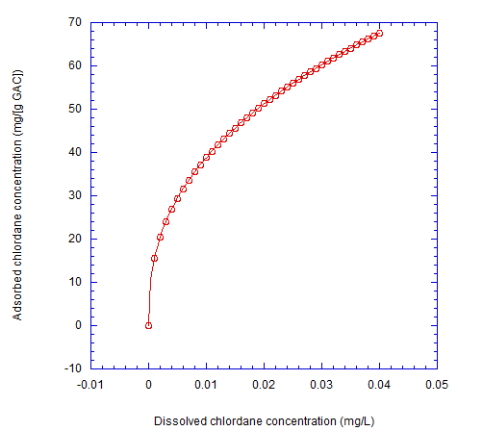

K = 245 $\left(\frac{mg}{g}\right)\left(\frac{L}{mg}\right)$

$\frac{1}{n}=$ 0.4

**Figure 4**. The data plots dissolved chlordane concentration, Caq vs. adsorbed chlordane

concentration, Cadsorbed. The reaction fits a Freundlich sorption isotherm, which

is displayed on the graph above with the K and n values.